Renewable energy

in the last 100 years

How has energy changed over time and how can renewable energy shape a sustainable future? What is Scotland’s role in renewable energy development?
This booklet can be used to explore the history of renewable energy, using archival resources from 1938 to shed light on the ways in which renewables have developed in the last century, with a particular focus on Scotland.
This booklet should be used alongside the context planner at https://radar.gsa.ac.uk/10417/ and https://resources.stemambassadors.scot/resources/empire-retold-including-augmented-reality-app/

Renewable energy in the 1930s
​Renewable energy is a modern priority, however, you might be surprised to learn that it was used a hundred years ago.
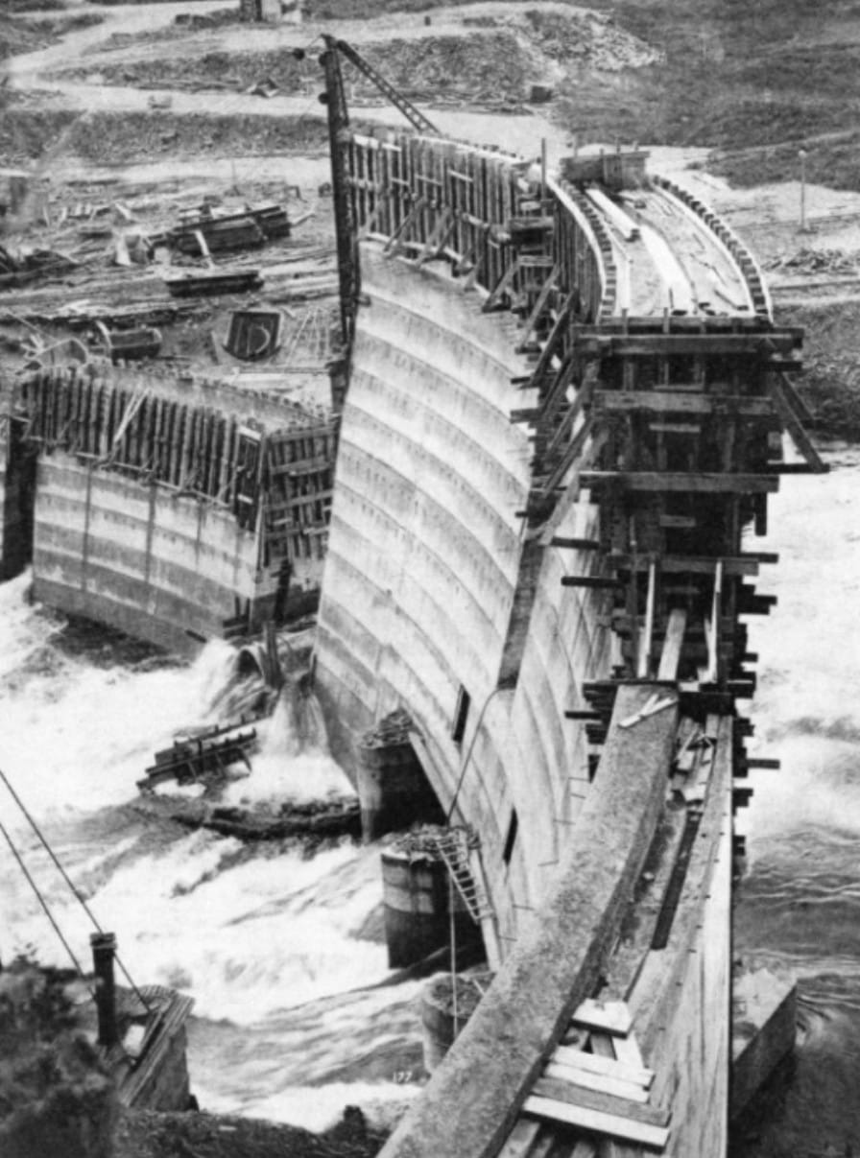
A great way to understand the development of, and attitudes towards renewable energy in the 1930s is to look at the ways it was mentioned in the 1938 Empire Exhibition in Bellahouston Park, Glasgow. This huge ‘worlds fair’ style exhibition celebrated Scottish industry, engineering, and manufacturing. It featured several exhibits highlighting advancements in hydro-electric power and its applications.​ Of course, this was alongside a celebration of the fossil fuel industry too!
Figure 1 - Earlstoun Dam in construction. Photo from https://wondersofworldengineering.com/galloway.html
Additionally, The Scotsman Trade Review dedicated a section to the "Development of Electricity," which featured Earlstoun Power Station which was constructed in 1936. This highlighted Scotland's advancements in electrical engineering and the role of hydro-electric power in the nation's industrial progress.
Earlstoun was part of The Galloway Hydro Scheme now operated by Drax. It originally involved five power stations. As part of this project, they even moved Loch Doon castle, stone by stone, from its original position in the centre of the loch to where it sits now!
​The construction took place during the Depression of the 1930s and provided much needed jobs. However, there was also opposition on grounds of fishing, aesthetics, coal interests, and community interests. Several other proposals for hydro power across Scotland in the 1930s were defeated by opposition. However, the Committee on Hydro-Electric Development in Scotland was set up in 1941 and, despite opposition by the Coal Owners Association (who had a powerful influence in Parliament), this led to the Hydro-Electric Development (Scotland) Act of 1943.
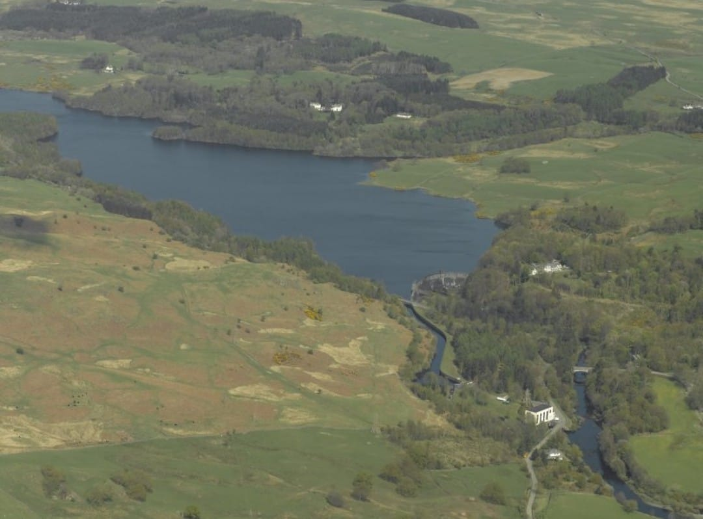
Figure 2 - Earlstoun Power Station today.

More information
More information about The Galloway Hydro Scheme can be found at
- https://www.bbc.co.uk/news/uk-scotland-south-scotland-56800934 and
- https://wondersofworldengineering.com/galloway.html
History of hydro stations in Scotland: https://en.wikipedia.org/wiki/North_of_Scotland_Hydro-Electric_Board

The 1938 Empire Exhibition
This exhibition has lots of relevance to the production and use of electricity. Visit this website and watch the video: https://sit.gsa.ac.uk/project/british-empire-exhibition-glasgow-1938 As you watch the video, try to spot places where electricity would have been needed to run the exhibition.

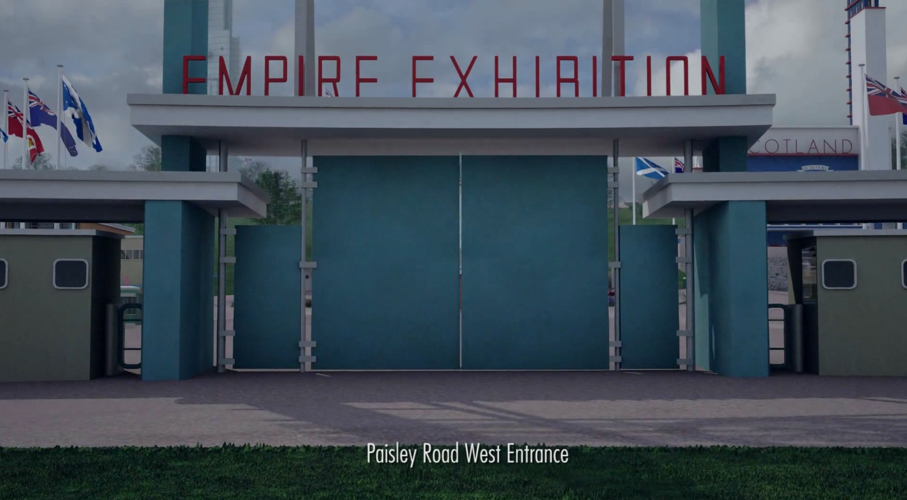
All of these pavilions used to be in Bellahouston Park, where there is only wide open space now!
Pay particular attention to these parts of the video, which show pavilions that had displays about electricity or power generation.
- UK govt pavilion 00:52s
- Women of Empire 00:58s
- Palace of Industries North 01.25
- Palace of Industries West 01.40 plus Industries, Shipping & Travel
- Palace of Engineering 02.10
- Main electric sub-station 02.35

Interactive 3D model
There is an interactive 3D model of the Empire Exhibition which you can download from https://radar.gsa.ac.uk/10417/. This model includes some guided tours, one of which focusses on energy and includes pavilions for Coal, Gas, Esso, Shell, the UK government, Women of Empire, and Glasgow City, all of which mentioned power production. Detailed information about these pavilions is included below.

Coal
The 1938 Empire Exhibition featured a dedicated Coal Pavilion that highlighted the significance of the coal industry within the British Empire. This pavilion was part of a broader effort to showcase the relationship between science and industry, emphasizing advancements in key national sectors such as coal, iron and steel, and shipbuilding.
The Coal Pavilion was large, with plenty of space to display various aspects of coal mining and its applications. The roof of the pavilion had chimneys which would shoot out sudden jets of steam!
One of the notable attractions within the UK Government pavilion was a working model of a coal mine, designed to educate visitors on the processes involved in coal extraction and the industry's technological progress. It also had displays showing what ancient forests looked like two hundred million years ago, and how coal is formed.
Other displays showed off the advances which led to improvements in efficiency in both in using coal for steam and appliances that enable electricity to be used more economically. There were even displays showing good and bad practice in handling the by-products of burning coal in power stations and heating our homes.
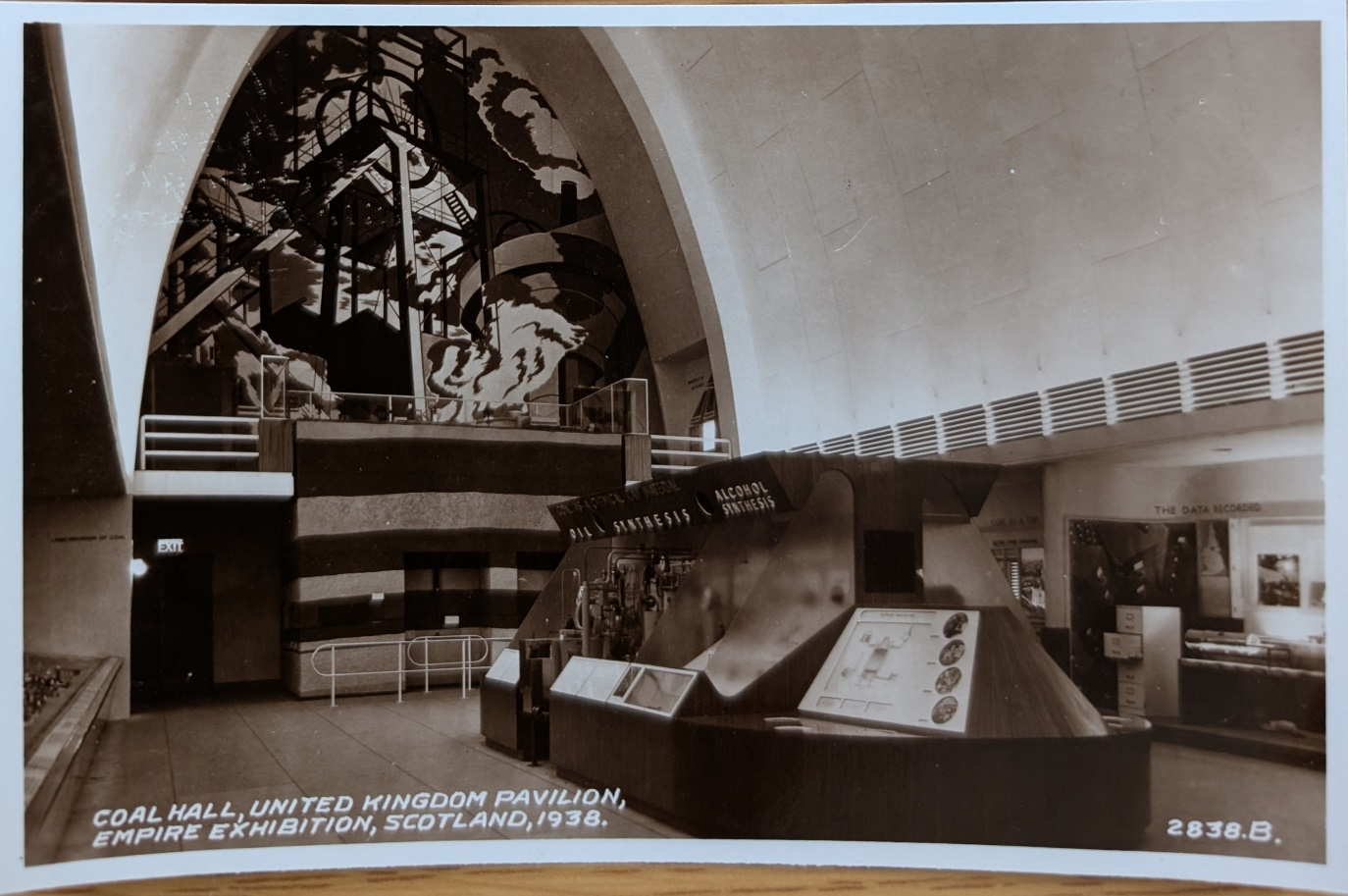
Figure 3 - a postcard showing the interior of the Coal Hall within the UK Pavilion. Notice the mural and different displays.

Gas
The British Gas Federation also had an exhibition within the Coal Hall in the UK Government pavilion. It showed how coal is carbonised in gasworks, the different methods of removing impurities, and the industries that relied on gas.

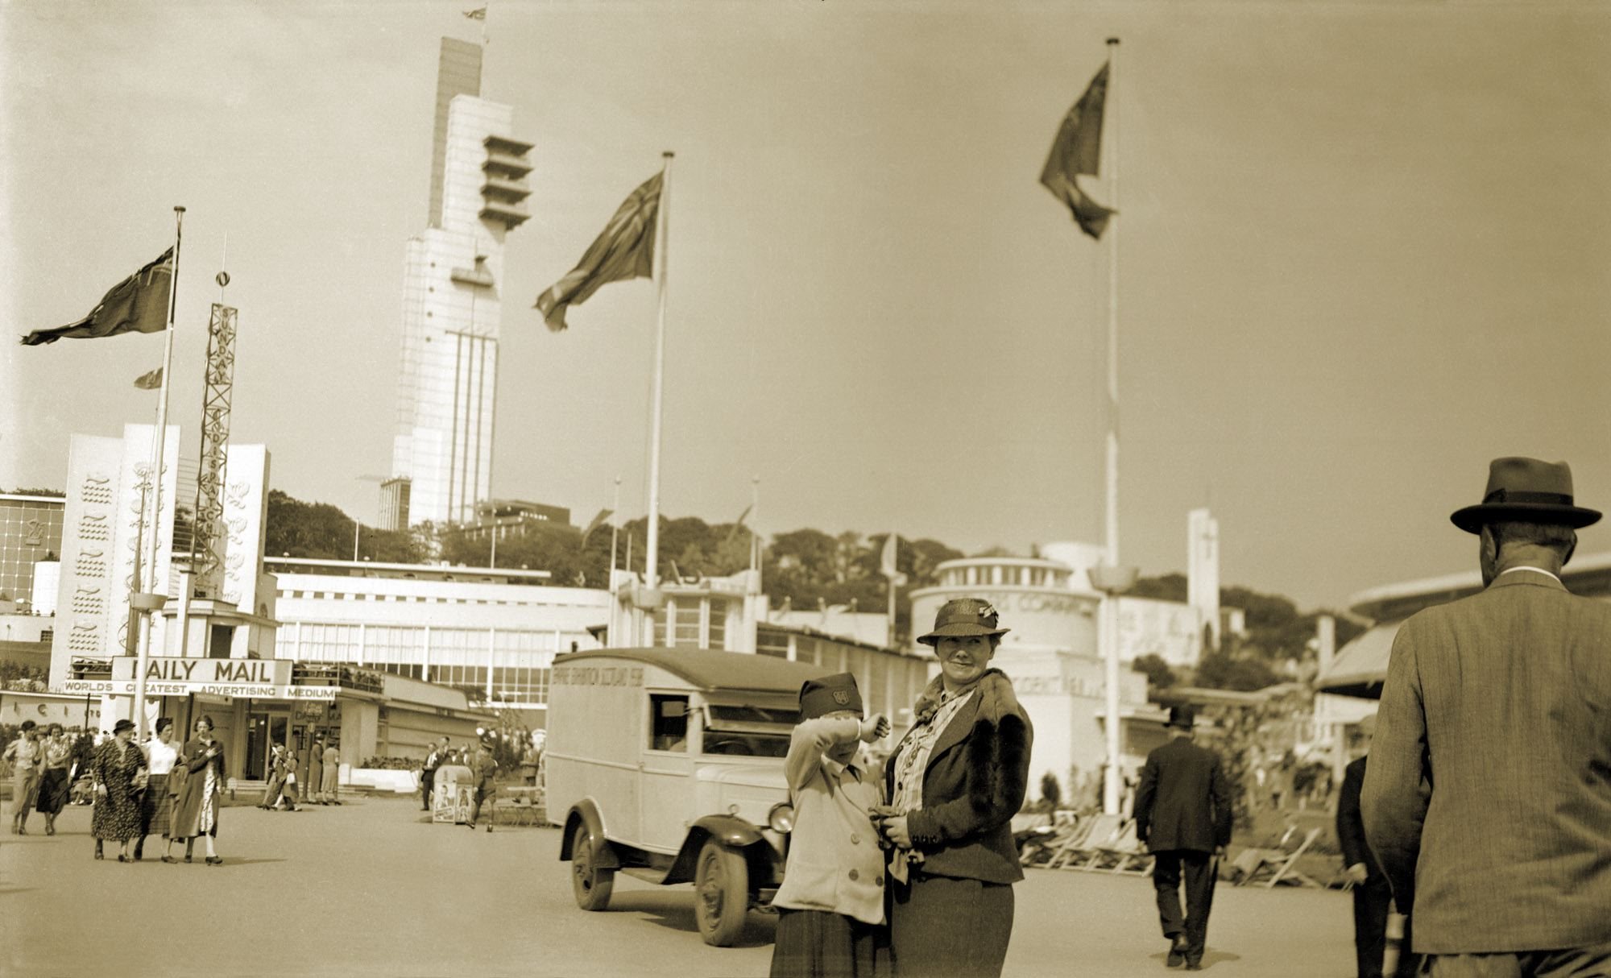
Figure 4 - the Gas Pavilion can be seen behind the truck in this photo from the archives about the exhibition.

Esso pavilion
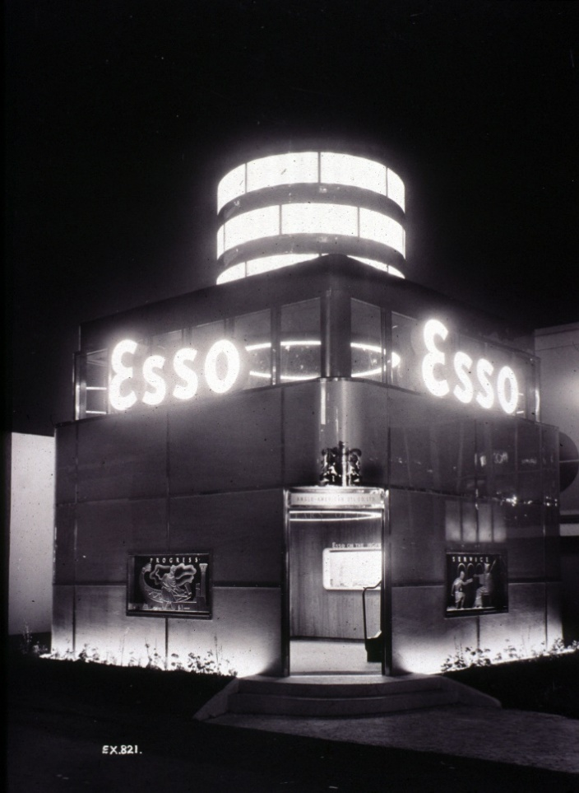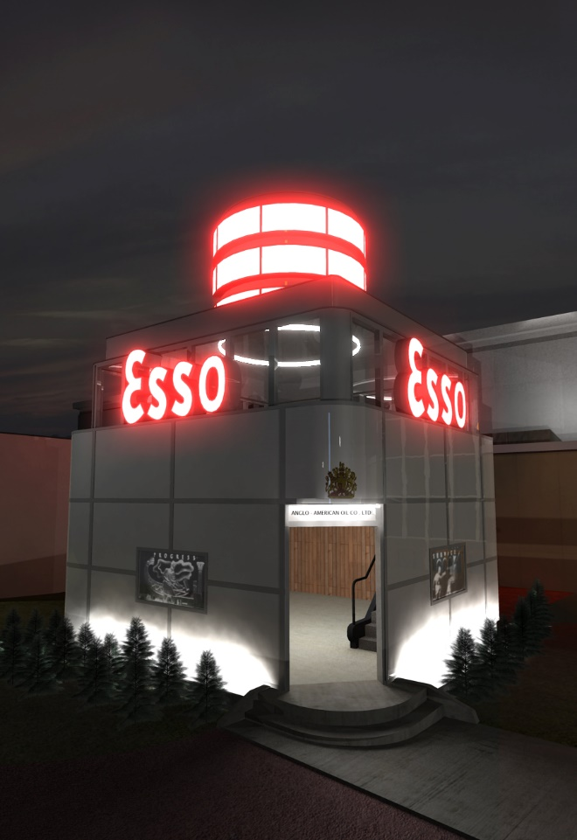
Figure 5 - a photograph of the Esso Pavilion alongside a 3d reconstruction, created by The Glasgow School of Art in 2010

Shell pavilion
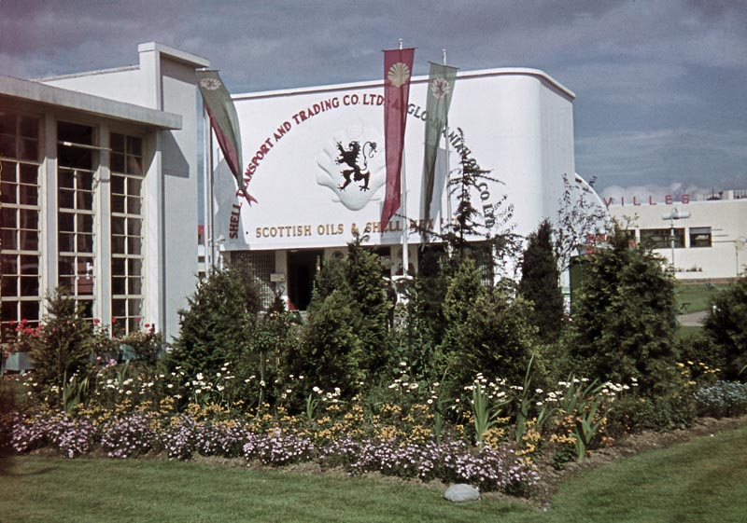
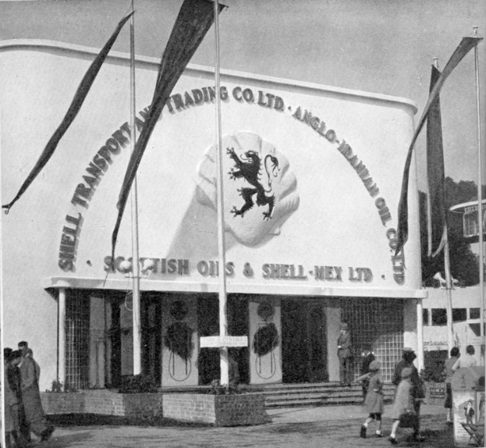
Some of the largest and most striking pavilions were created by companies such as Shell. Notice the title of the pavilion: Shell Transport and Trading Co Ltd, Anglo-Iranian Oil, Scottish Oils & Shell-Mex Ltd.
Figure 6 - photographs of the Shell pavilion

Palace of Industries
The Palace of Industry West was one of the most significant structures at the exhibition. Despite its huge size, there were so many exhibitors that one one pavilion could not fit them all in! Therefore, the Palace of Industry North was a late addition to the exhibition plans, added to house the overspill of industry exhibitions.
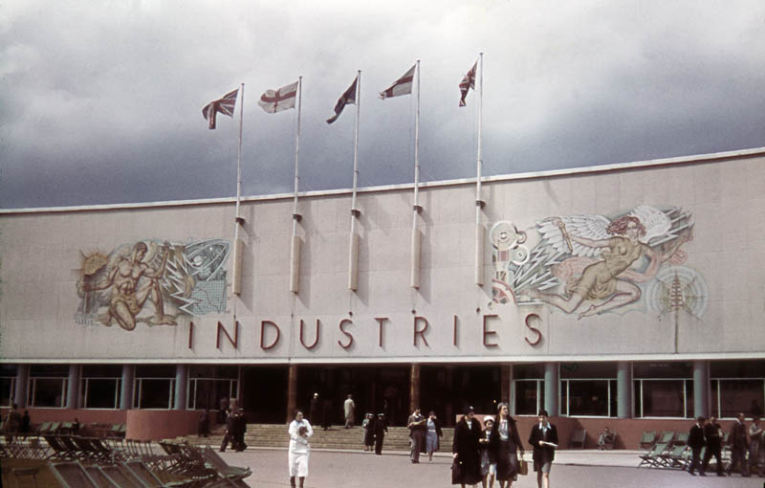
Figure 7 - a photograph of the Palace of Industries (West), showing the mural of the "Angel of Energy" by John Christie of Guthrie & Wells.
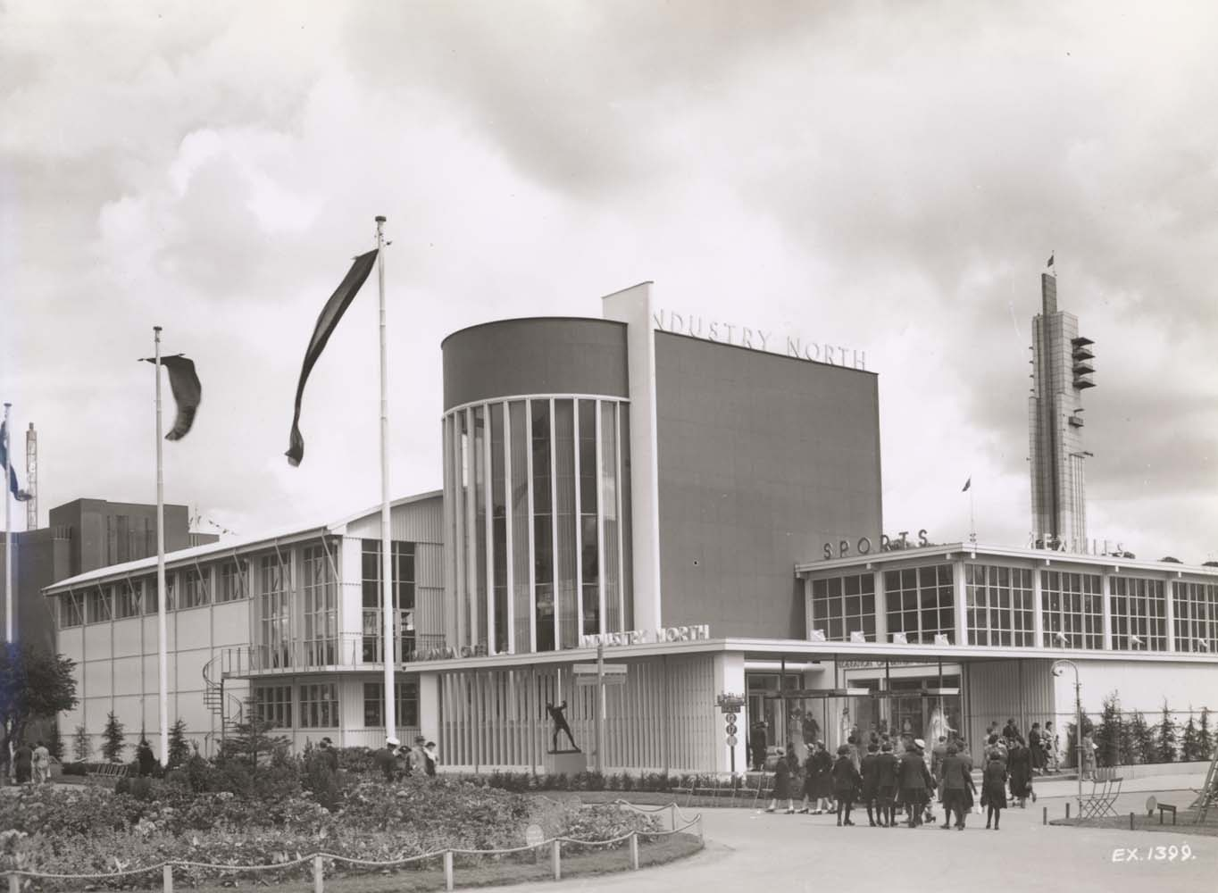
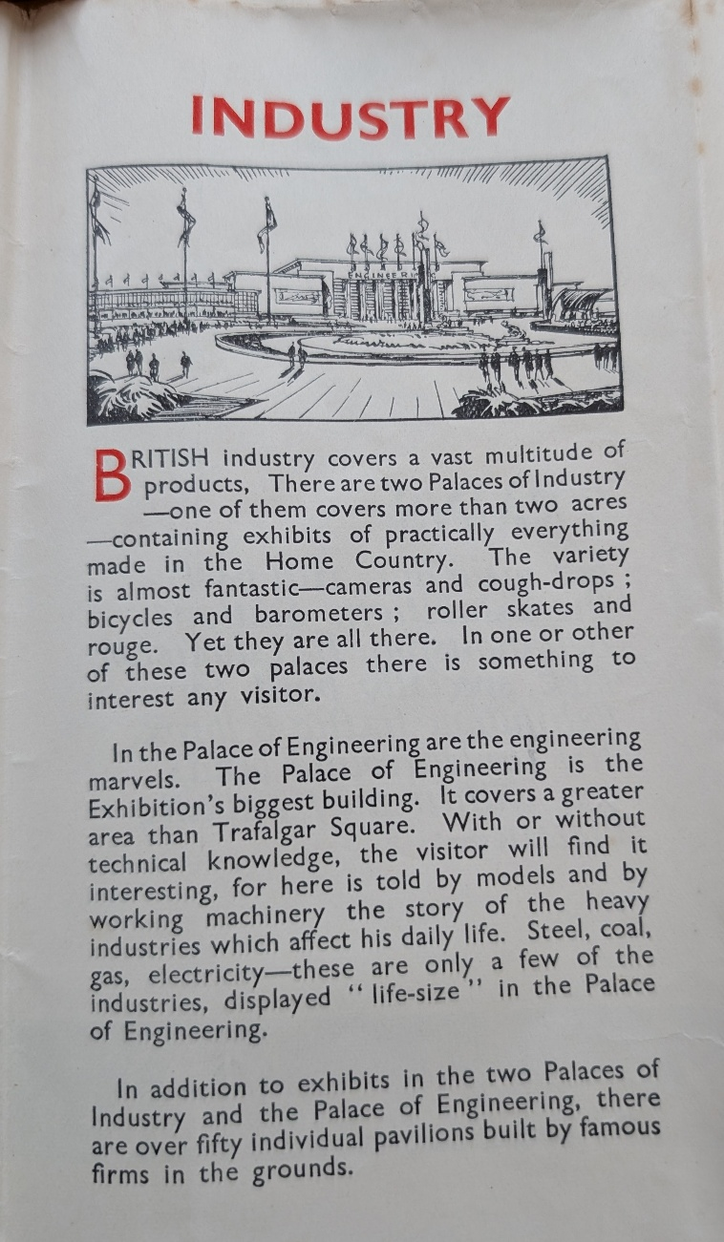
Figure 8 - photograph of the Palace of Industries (North)
Figure 9 - extract from a souvenir map of the Empire Exhibition

Women of Empire
The Women of Empire pavilion held a diorama called “From Waterfall to Washer!” in the cultural section, as part of the Electrical Association of Women stand. It showed a working model which illustrated how electricity, harnessed from natural sources like waterfalls, could be utilized for domestic tasks, emphasizing the practical benefits of hydro-electric power in everyday life. Nina Baker, historian for the Electrical Women’s Association built a Lego version of the diorama.
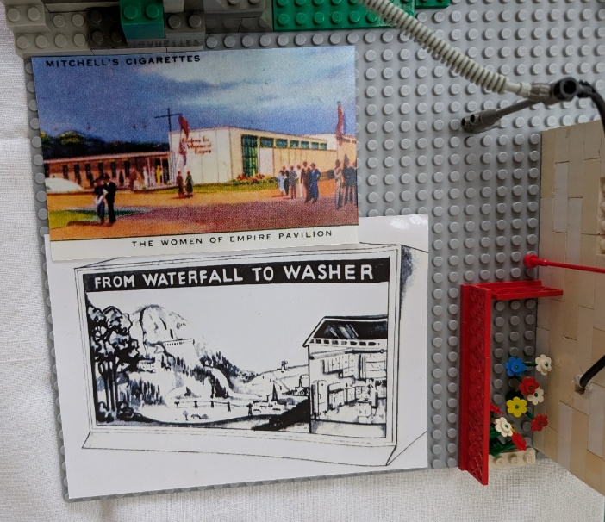
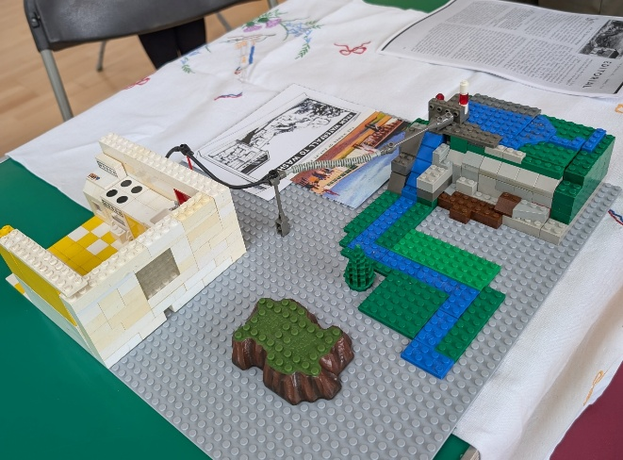
The Electrical Association for Women held a national conference at the 1938 Exhibition. It was themed “The New Way of Living – Women’s Work in the Modern World.”
Figure 10 - lego reconstruction of a diorama showing how hydro power gets to homes. By Nina Baker.
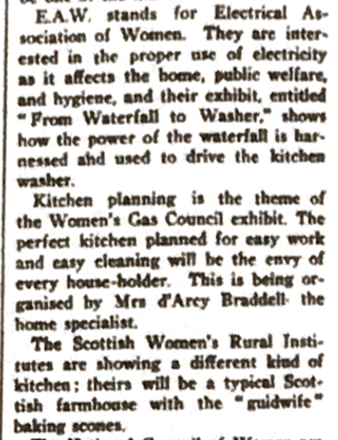
Figure 11 - a newspaper clipping from the Broughty Ferry Guide and Carnoustie Gazette, March 19th 1938

City of Glasgow Pavilion
The City of Glasgow Pavilion showcased the city's four major trading departments: Water, Transport, Gas, and Electricity. It highlighted Glasgow's advancements in public utilities, including hydro-electric power.

More information
https://www.nature.com/articles/141860a0
https://jdpecon.com/expo/wfglasgow1938.html
https://www.theglasgowstory.com/image/?inum=TGSA00411&t=2
https://glasgowimperialcity.wordpress.com/2013/05/10/the-1938-glasgow-empire-exhibition-75-years-on/
Bruce Peter (2025) "Art Deco Scotland: Design and Architecture in the Jazz Age"

Your response to the materials
- What is the main way that attitudes towards renewable energy have changed in the last hundred years?
- How do some of the debates about the construction of hydro electric power stations in the 1930s reflect current debates about e.g., windfarms?
- Efficiency of power production from fossil fuels was an issue even a hundred years ago. What major advancements do you think have been made since then?
- How is hydroelectric power represented within the Women of Empire pavilion? Why do you think this is?
- What has changed about the way in which we learn about both fossil fuels and renewable energy between the 1930s and today?
- What is Scotland’s role in renewable energy development? Which renewable energy sources is Scotland leading in?

About this booklet
This booklet can be used to explore the history of renewable energy, using archival resources from the Empire Exhibition of 1938. It was written by Dr Daisy Abbott as part of “Decolonising the British Empire Exhibition of 1938 through Augmented Reality Narratives”, a research project at The Glasgow School of Art, 2024-2025.
This booklet can be used alongside the context planner at https://radar.gsa.ac.uk/10417/ and https://resources.stemambassadors.scot/resources/empire-retold-including-augmented-reality-app/
More information about this project can be found at https://sit.gsa.ac.uk/project/decolonising-augmented-reality where you can also download related resources such as lesson plans, digital applications, and workshop templates.
This project was funded by the Arts and Humanities Research Council.

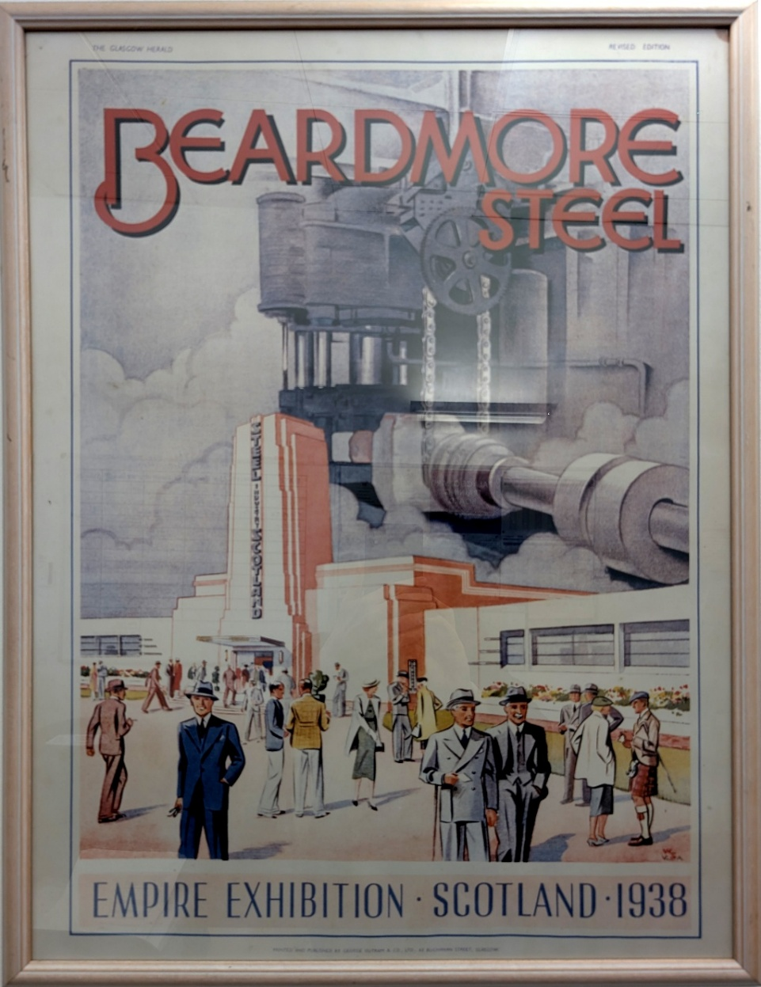

Berry-Waite, Lisa (27 May 2024). "'Screwdrivers, Scissors and Pliers': The Electrical Association for Women in Interwar Scotland – Eleanor Peters". Women's History Network; ‘The Empire Gathers at Glasgow’, Electrical Age 3, no. 10 (1938): 373; Editorial, The Electrical Age, Summer 1938, pp.409-410

